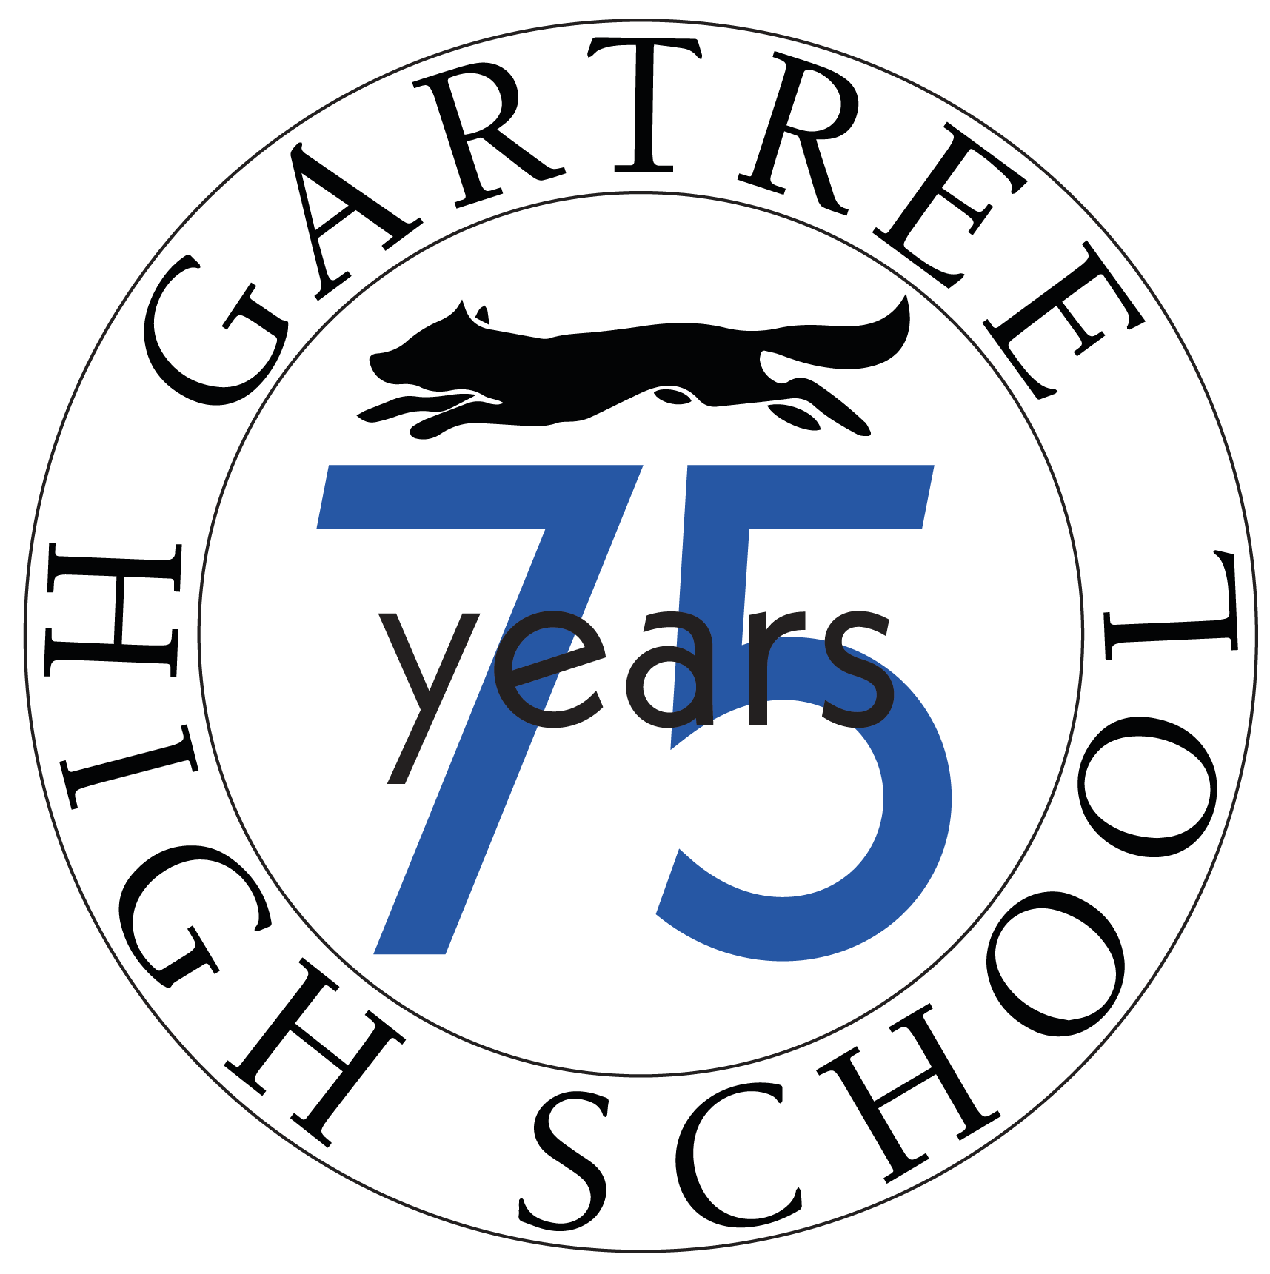
Gartree High School
Ridgeway, Oadby, Leicester, LE2 5TQ

23rd April 2022

Dear Applicant,

Head of Computing
MPS/UPS plus TLR2b £5,354
Full time/part time and job share will be considered

Thank you for your interest in this post which is available from August 2024.

We wish to appoint a person who is relentless in their drive for improvement and will enhance the capacity of our Leadership Team to take our school forward. Other information such copy of the latest Ofsted inspection report is available on our website. All of this information should help you to get a better picture of what we believe is an excellent and high-achieving school.

We are looking for an optimistic, enthusiastic, caring and energetic teacher of Computing who is passionate about the subject and inspirational to their students. The post offers an ideal opportunity for an individual to lead the department and develop an innovative and inspiring approach to Computing at KS3 and GCSE.

Gartree High School is an outstanding High School that prides itself on the learning experience offered to our pupils. The post holder will ensure that all aspects of performance in Computing is of the highest quality. You would have the opportunity to teach enthusiastic, engaged young people who display outstanding behaviour and be fully supported in your professional development. Main scale teachers with drive, ambition and great leadership potential are very welcome to apply; full support in post will be given.

If you like what you read and are committed to help us to further improve educational experiences for our young people and to the principles which guide our work, then I very much look forward to receiving an application from you. Please enclose a letter, which should be no longer than two sides of A4. In this, I would like you to tell us why you wish to join Gartree High School and outline your experience to date, and how it has prepared you for this role. Please note curriculum vitae will not be accepted.

The closing date for applications is noon on Monday 13th May. If you have not heard from us by Wednesday 15th May then please assume that, on this occasion, your application has been unsuccessful.
Yours sincerely,

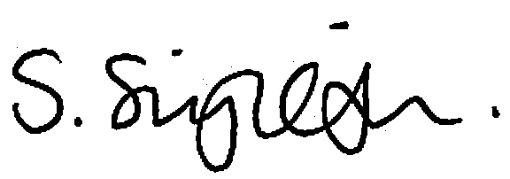

Sonia Singleton
Headteacher

