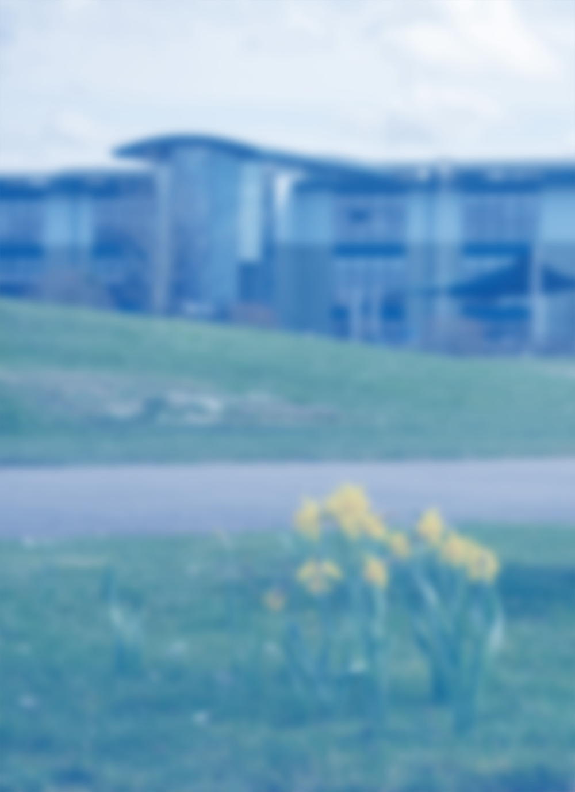

Facilities & Equipment

**Gartree IT Department**

* 2 ICT suites with 33 computers and wide screens.
* Full site wi-fi 6 with Staff and Guest access.
* 48 bookable iPads and a range of departmental iPads for use.
* Music suite with 18 computers and midi keyboards.
* A further bookable room of 22 machines, located in our band new building.
* Bookable Library with 20 pupil accessible machines.
* State of the art Promethean boards in all classrooms.
* Follow me printing and copiers using identity cards.
* Fully cashless catering system using facial identification.

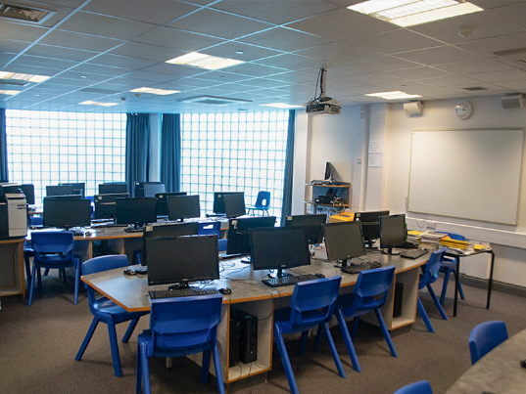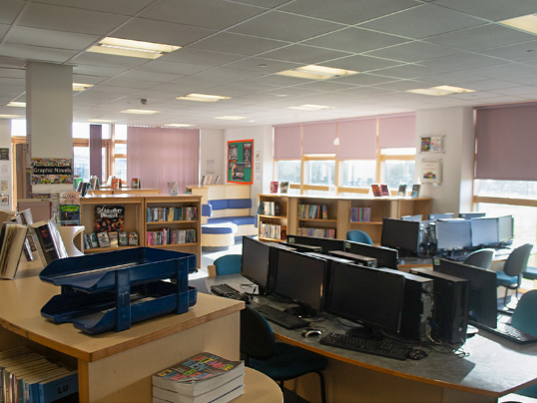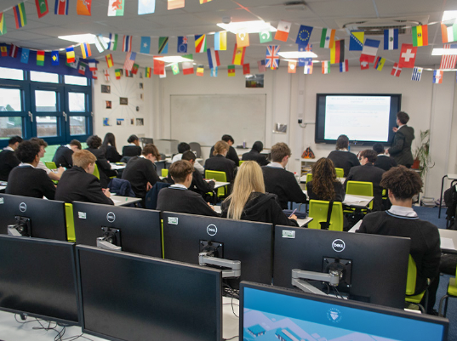

* Access to the full Office 365 suite in school and on home computers.
* Access to the full suite of Photoshop Programs.
* SENSO and Impero classroom management/safeguarding software along with Smoothwall web filtering helping pupils stay on task.
* Bromcom Cloud MIS for data and pupil management.

Software

“Computer Science at Gartree is a very practical subject – students will be able to use their knowledge and skills they learn in the classroom on real-world problems. We encourage students to think creatively, innovatively and logically to develop valuable thinking and programming skills that are extremely attractive in the modern workplace.”