Extra – Curricular Sport Timetable:
Summer Term 2: 26th Feb – 22nd March

Day | After School Club
Monday | Y8/9 Dodgeball  KS3 Girls Rugby
Tuesday | 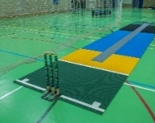  KS3 Indoor Cricket  KS4 Fitness
Wednesday | 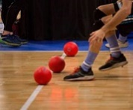  Cheerleading (lunchtime)  Y7 Dodgeball/Tchoukball  KS4 Fitness
Thursday | KS3 Gymnastics  KS4 Fitness
Friday | 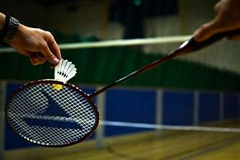  Dance Club – (lunchtime)  KS4 Badminton

