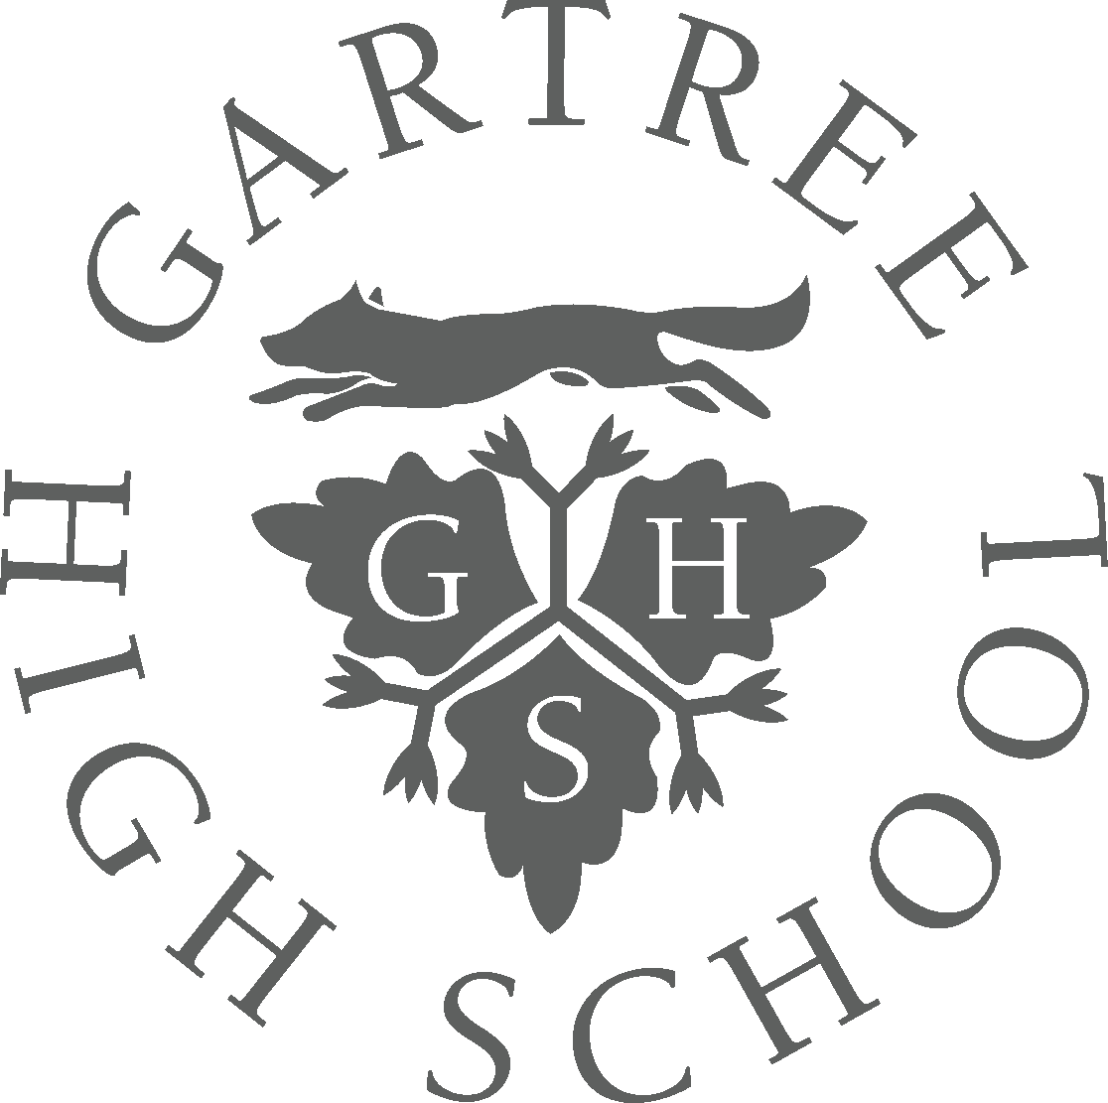
Gartree High School Term Dates
2024/2025

Autumn Term 2024
School opens Tuesday 27 August 2024
Half term break Monday 21 October to Friday 25 October 2024
School closes Friday 20 December 2024

Spring Term 2025
School opens Tuesday 7 January 2025
Half term break Monday 17 February to Friday 21 February 2025
School closes Friday 11 April 2025

Summer Term 2025
School opens Monday 28 April 2025
Half term break Monday 26 May to Friday 30 May 2025
School closes Wednesday 9 July 2025

Teacher Days 2024/25
Thursday 22 August 2024
Friday 23 August 2024
Monday 6 January 2025

